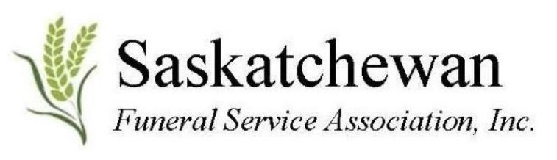
2026 SFSA Non-Golf Activity Tours, Saskatoon
May 25th, 2026

Contact Name: __________________________________________________
Company Name (if applicable): _____________________________________
Cellular Phone #: ________________________________________________
Email address: __________________________________________________

____ Yes I want to attend the Non- Golf Activity Tour
____ Yes I want to attend the Non- Golf and Reception ($50)
____ Yes I require a GF meal

ITINERARY SCHEDULE (COST IS COMPLIMENTARY TO YOU)
12:30 p.m. Bus shuttle pickup from Alt Hotel (480-2nd Ave S)
01:00 p.m. Tour of Stars Ambulance
02:00 p.m. Bus shuttle to Dutch Growers
02:30 p.m. ‘Tour with Sip ‘n Shop’ Event at Dutch Growers
04:00 p.m. Bus shuttle to Greenbryre Club 19 Reception
04:30 p.m. Happier Hour (cash bar)
06:00 p.m. Buffet Ukrainian meal
07:00 p.m. The Day Awards presented
07:15 p.m. Entertainment- Kelly Taylor
08:15 p.m. Socialize
09:00 p.m. Bus Shuttle back to Alt Hotel

SPACE IS LIMITED to FIRST 40 people by May 1st, 2026.
Return this completed form to jdschack@hotmail.com
Please e-transfer $50 for the reception to saskfsa2019@gmail.com

IF you are a Supplier, or just interested, please send 100 of your Engraved Company Token items for the Swag Bag for each Golfer and Non-Golfer and ship to:
SFSA c/o 311-3rd Avenue North, Saskatoon, S7K 2H9 by MAY 7th, 2026

